**Finding study sets**

1. Go to [quizlet.com](http://quizlet.com/) and log in.
2. Select **Search**.



1. Type in the topic you are looking for, e.g. Marketing.



1. Press **Enter**.

The search results default to study sets and you can filter the results by diagram sets, classes, or users.

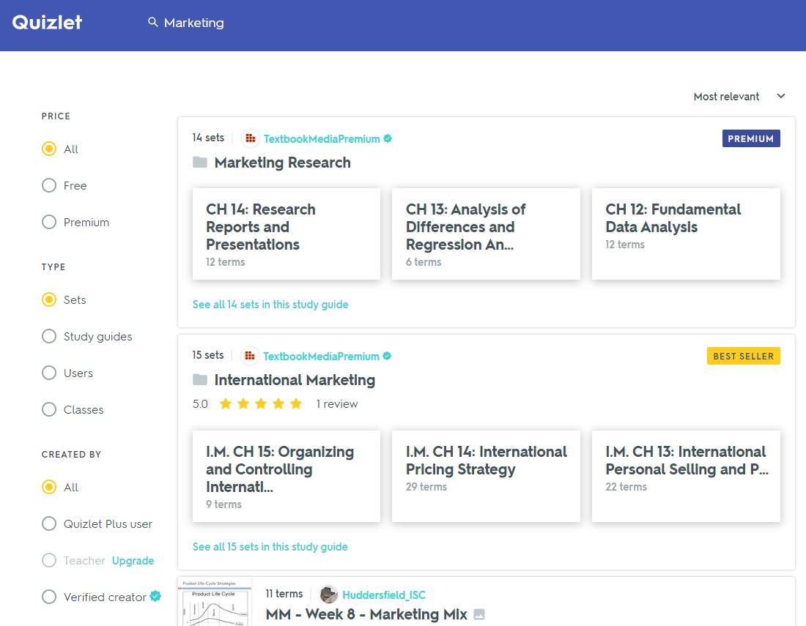

**Adding a set to a folder**

1. Open the set you want to add.
2. Expand the menu located below the flashcard at the top by clicking on the three dots symbol.

****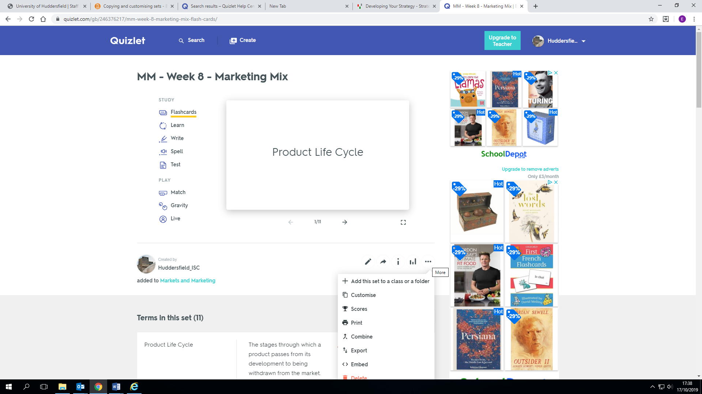

1. Select the Add this set to a class or folder option and then Add to folder to open the list of available folders.

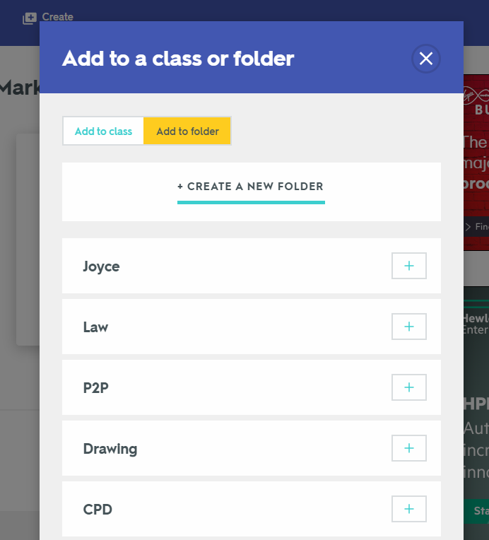

1. In the list, locate the folder you want to add the set to and click on the plus sign (+) next to it. The set will be added to the folder.